* **Full Name:** Romone Gordon
* **Student ID#:** 2403205
* **Assignment:** Individual Assessment 02
* **Day/Time of Class:** Tuesday/11:00am UE1
* **Module Name/Code:** Web Programming / CIT2011

**Storyboard**

**1. Wireframe**

Login Page-

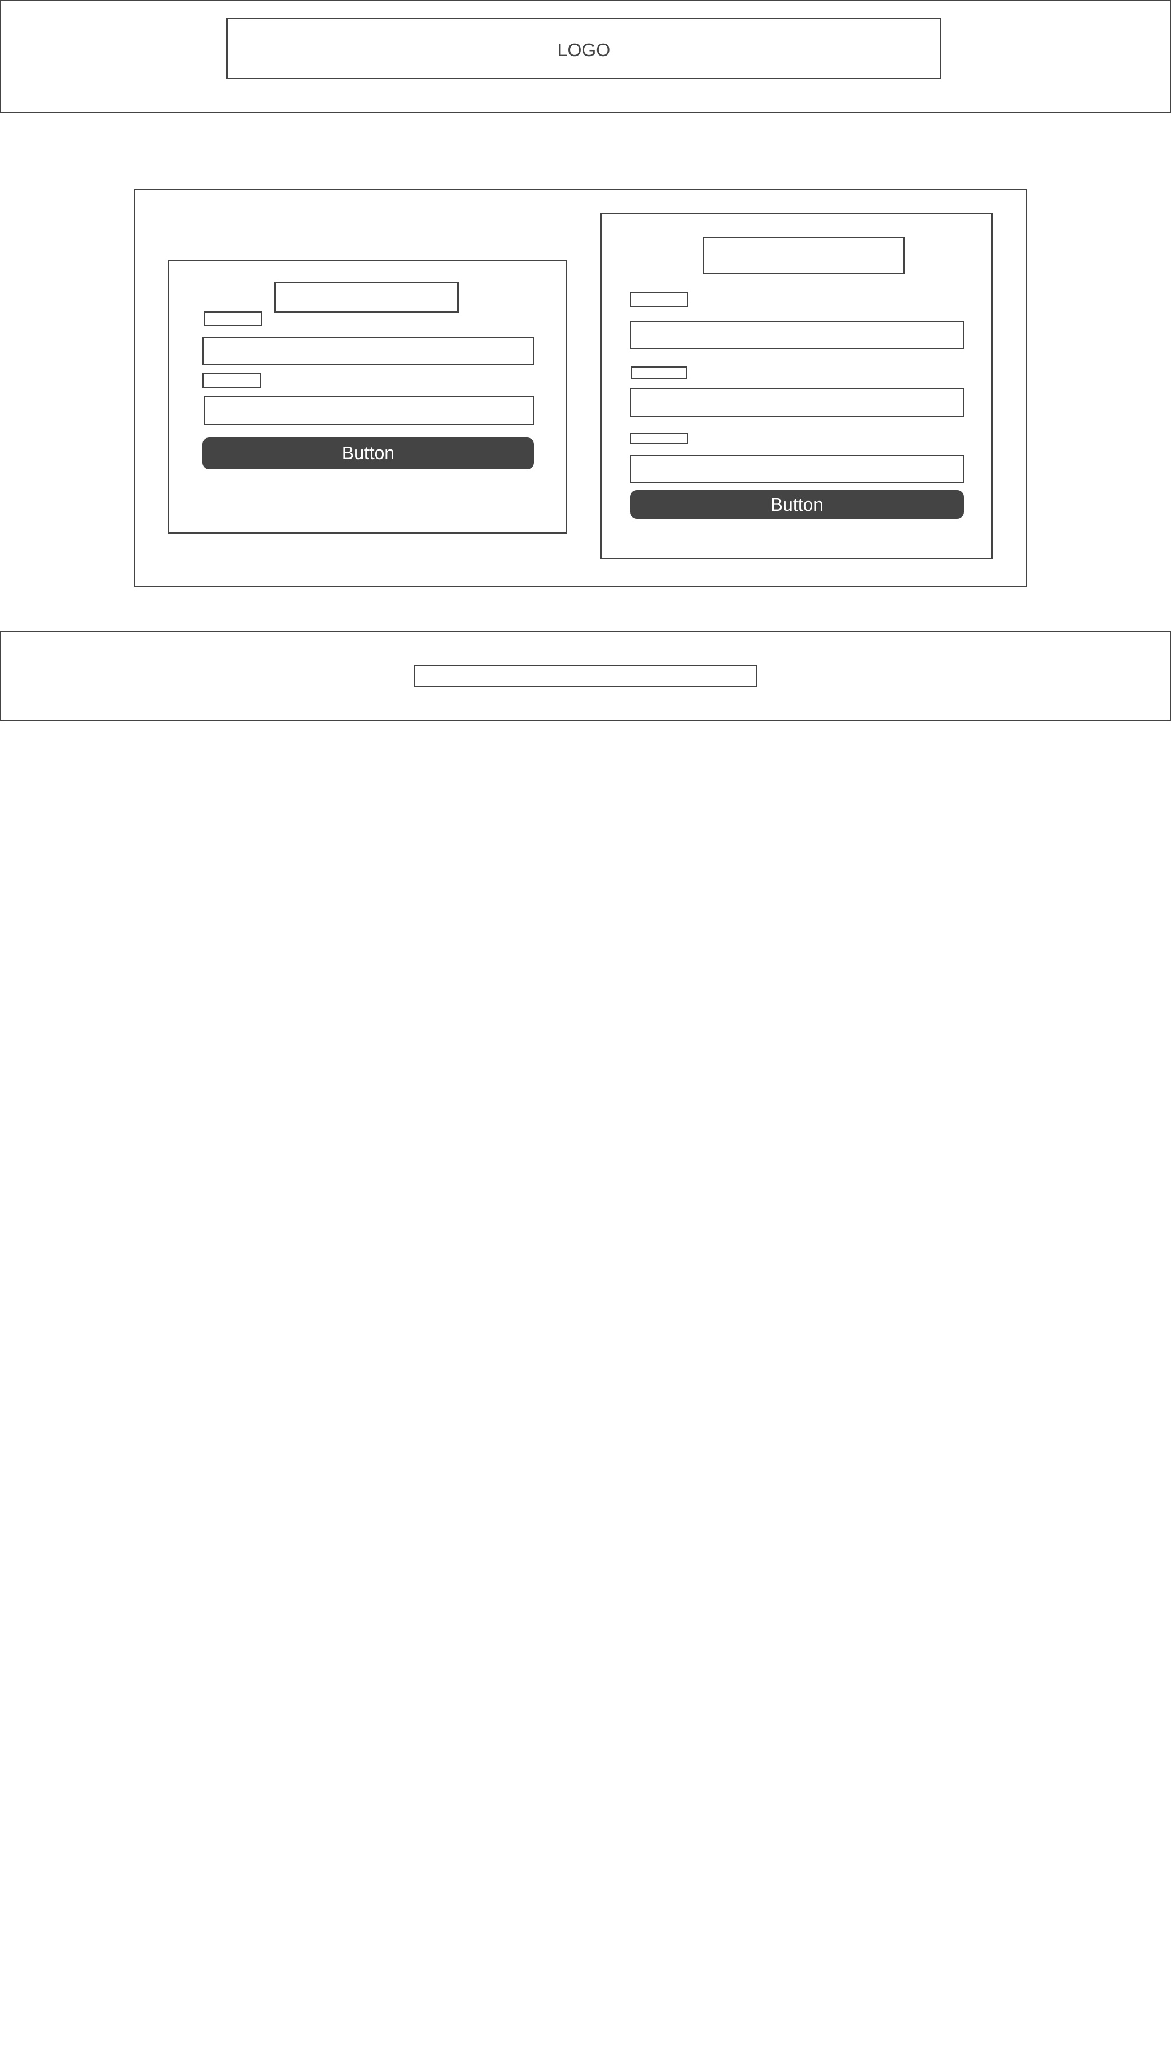

Products page-

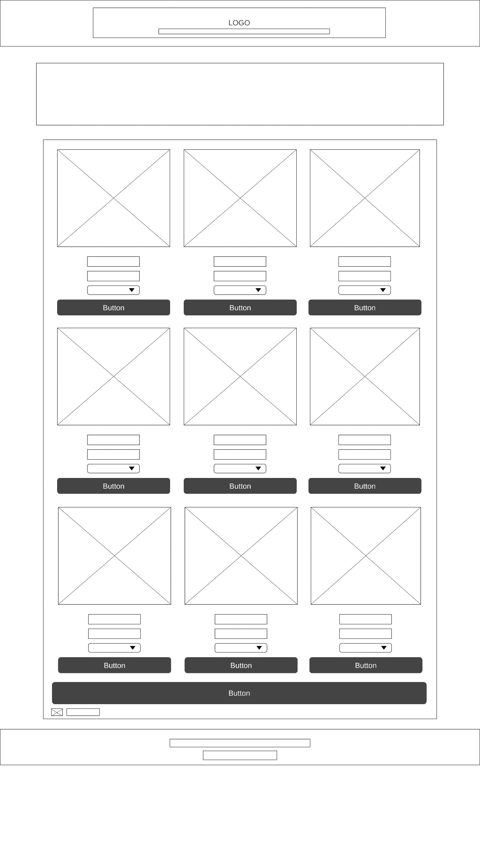

Cart page-

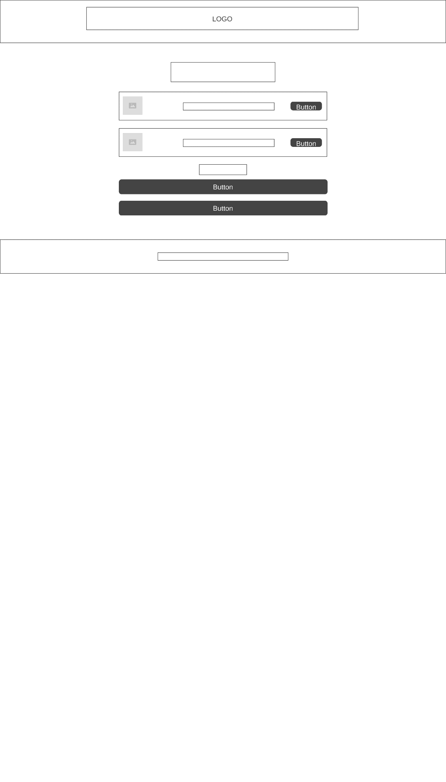

Invoice Page-

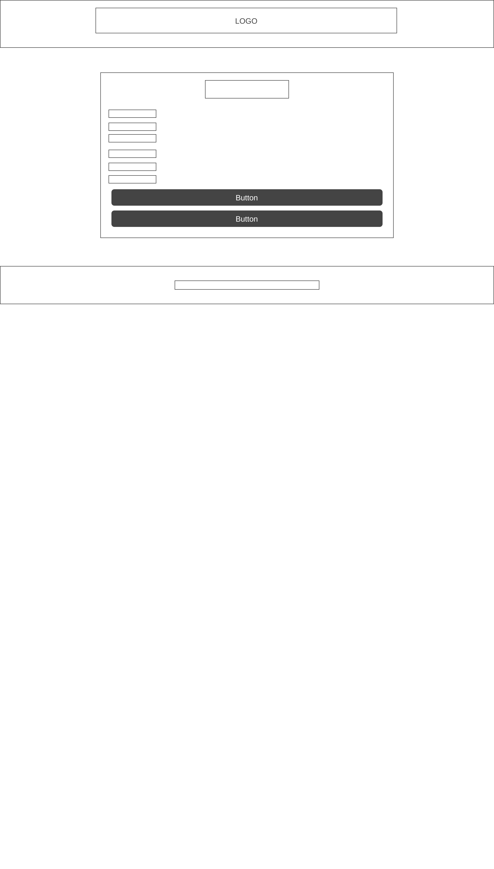

Thank you Page-

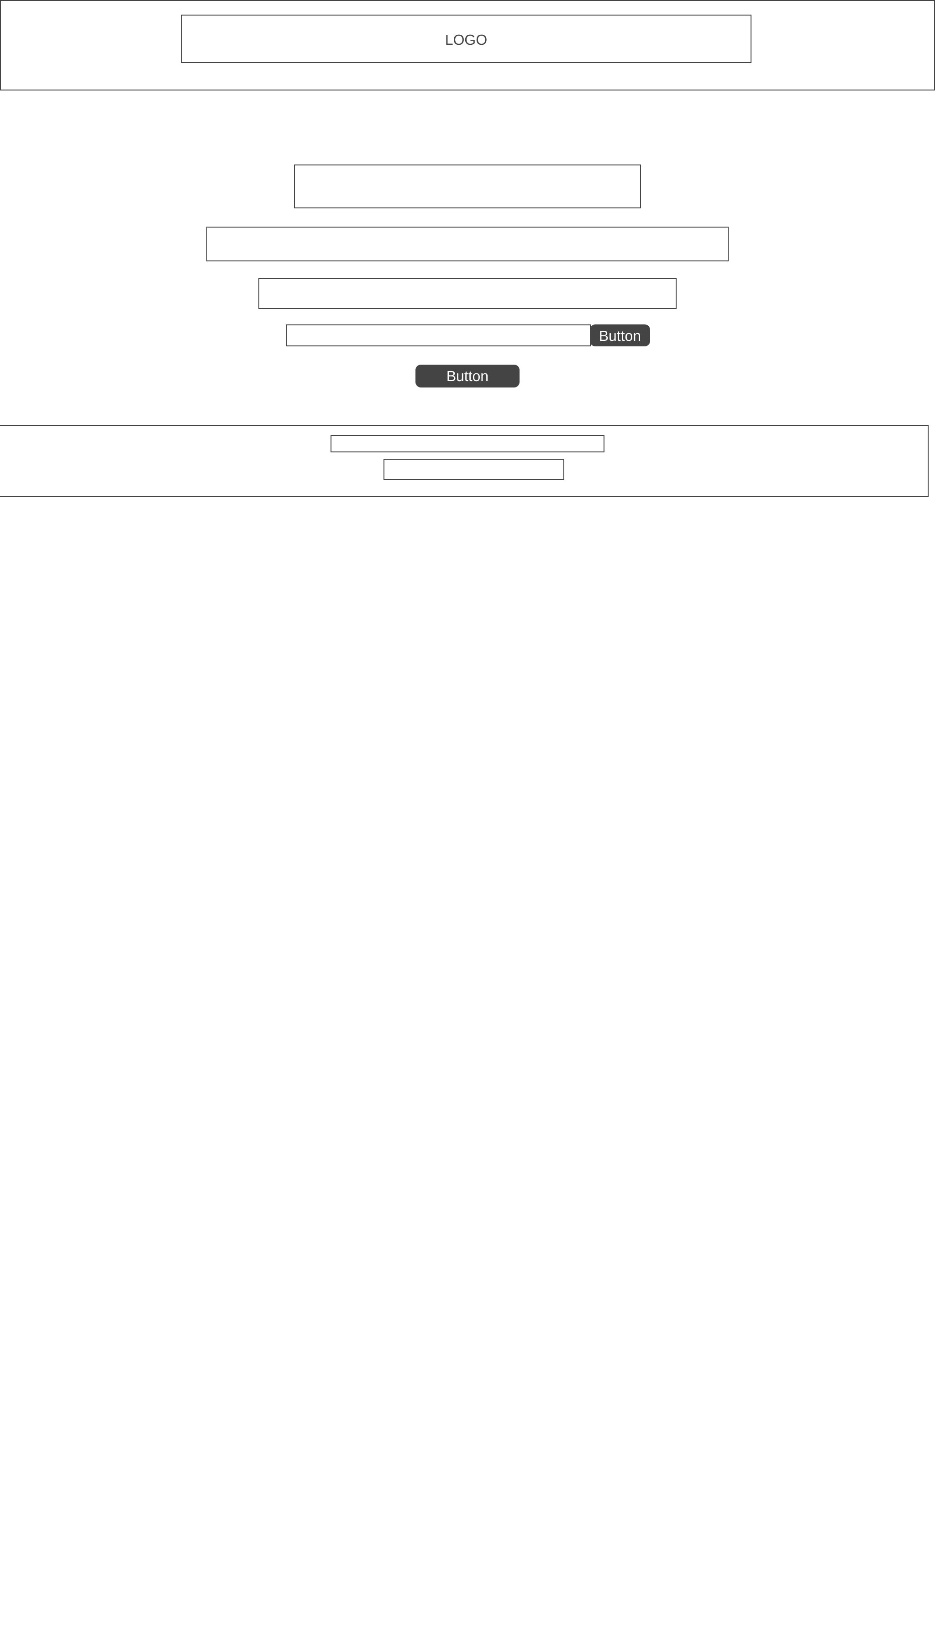

About Page-

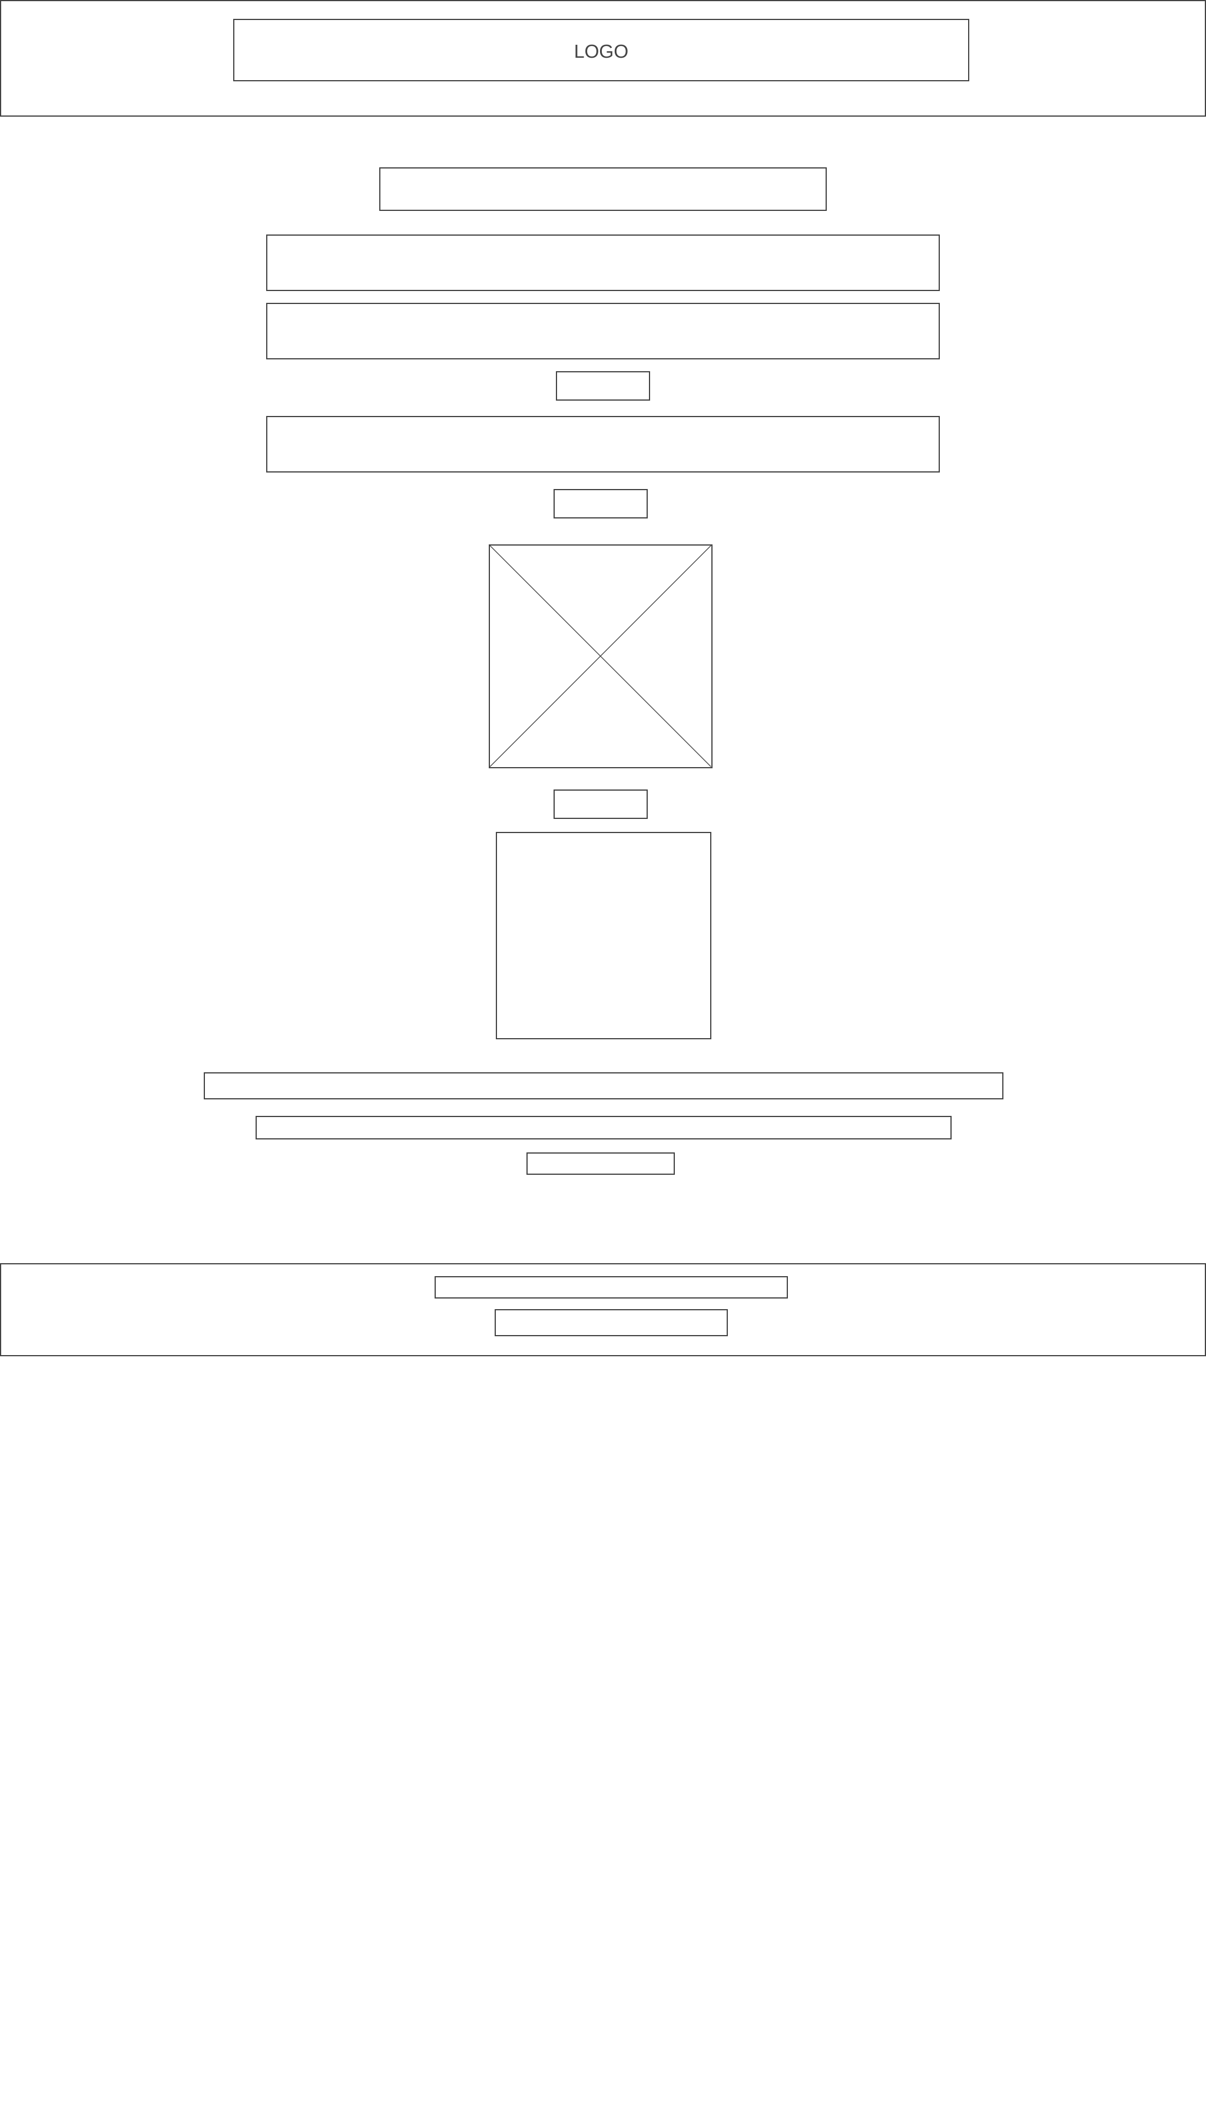

**2. Business Description**

**Business Name: Gordon's Royalty Shoes**

Gordon's Royalty Shoes is an elite shoe company that focuses on simple, black, and white shoe designs. Our shoes have a sleek and upscale appearance, appealing to those who value understated yet fashionable footwear.

**Slogan:**

* **Slogan:** “Designed for the unknown to be known”

**Mission Statement:**

To offer premium, personalized shoes that combine exclusivity and minimalism so that our clients may always go out with assurance.

**Vision Statement:**

To establish ourselves as the leading source for fashionable yet understated custom shoes, providing distinctive styles for those who value understated elegance.

**3. Justification of Color Palette**

The main color palettes used on our website are Black, white, and light gray tones. This is consistent with the identity of the brand and the psychological effects of color:

• Black: Stands for exclusivity, sophistication, and elegance.  
• White: Denotes professionalism, neatness, and simplicity.   
• Gray: Gives the designs a contemporary, well-balanced touch without taking over.

All of this is done is effort of showcasing our simplicity and minimalism as we believe bold colors and bold designs draw unwanted attention and criticism; where when wearing one of our elite shoe-wear guys the wearer a free mind to not be judge but rather admired for the subtle styling.

Reference: Inspiration came from https://www.nike.com as it showcases a similar color palette.

**4. Intended Audience**

Our target market includes:

* People seeking personalized shoes that provide a distinctive, subtle style.
* Young professionals and urban fashion aficionados who value premium, exclusive footwear.
* Customers who favor high-end goods with simple, minimalistic aesthetic.

**References**

* • Nike. (n.d.). *Nike Official Website*. Retrieved March 9, 2025, from <https://www.nike.com>
* • GenCraft. (n.d.). *GenCraft AI Art Generator*. Retrieved March 9, 2025, from <https://www.gencraft.com>
* • Canva. (n.d.). *Canva Online Graphic Design Tool*. Retrieved March 9, 2025, from <https://www.canva.com>
* • Under Armour. (n.d.). *Under Armour Official Website*. Retrieved March 9, 2025, from <https://www.underarmour.com>